Nicholas Sammut

CSC 425 – Mobile Computing

Dr. Mark Allison

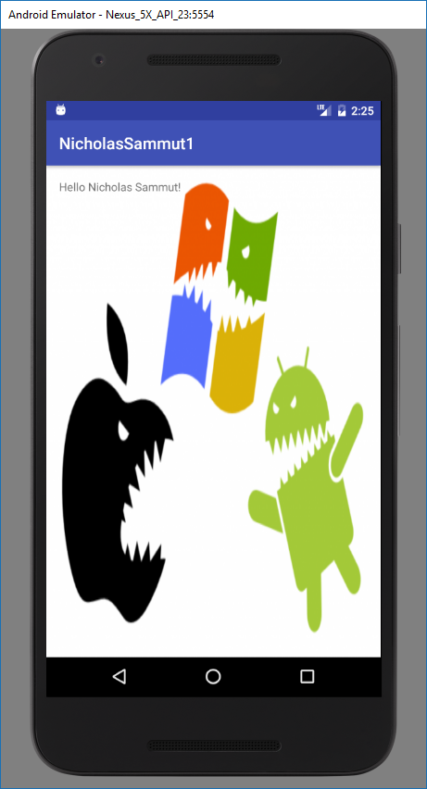Homework 1

Image of Emulator Running

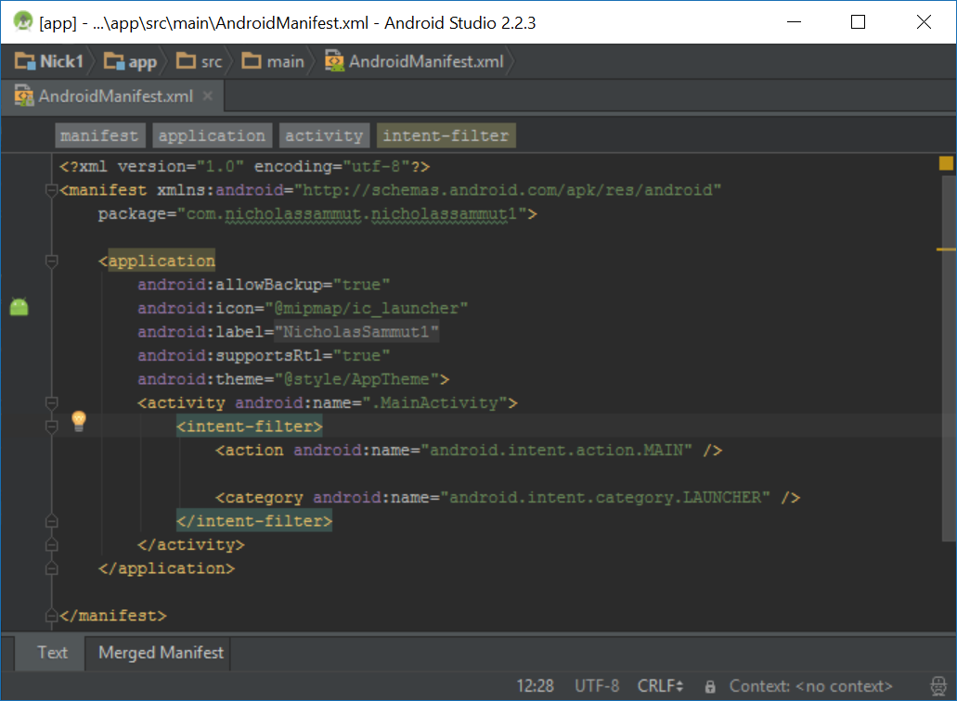

­Image of Android Manifest File